Strengthening coordinated water, land and ecosystem management in UN Sustainable Development
Cooperation Frameworks in Africa

Concise assessment guideline

Introduction
The objective of this concise assessment guideline is to provide an introduction into how to assess, and provide inputs to, UN Sustainable Development Cooperation Frameworks (UNSDCFs) and Common Country Analyses (CCAs), in the context of coordinated water, land and ecosystem management to support multiple development objectives. The aim is to support UNEP Africa Office personnel to in turn support UN Country Teams to meet this objective.

This guideline is intended to be concise, rather than comprehensive, developed in the context of the initial phase of the initiative on mainstreaming water resources management within UNSDCFs. It builds on the experience of developing the Rapid Needs Assessment in the initial phase. This guideline may be further developed during a subsequent phase. More comprehensive guidance may be found in “Guidance on integrating the environment and climate change in processes for United Nations Sustainable Development Cooperation Frameworks”, developed by the Issue-based Coalition on Environment and Climate Change for the pan-European region, 2021.

Entry points
The entry points for mainstreaming are:
- Country Framework Roadmap
- Common Country Analysis (CCA)
- UNSDCF design
- UNSDCF implementation (Joint Work Plans)
- UNSDCF monitoring and evaluation (see Figure 1)

This guideline focuses on the CCA and UNSDCF design phase.

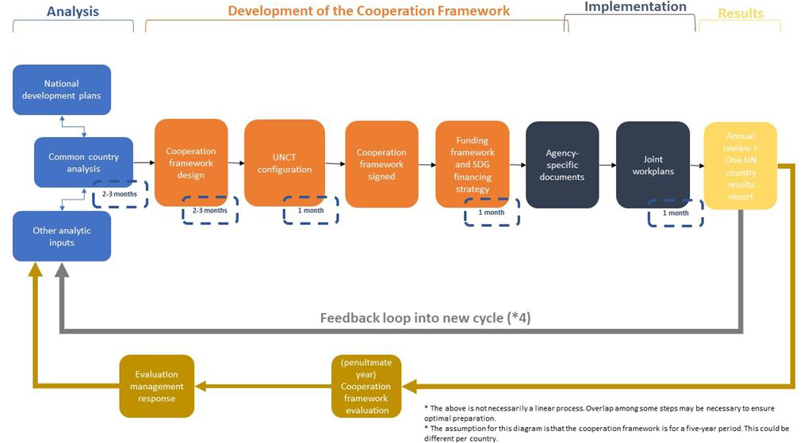
Figure 1 The Cooperation Framework cycle. Source: UN Sustainable Development Group 2019

Linkages to national, regional and global development priorities
The work of the UN Country team (CCA, UNSDCF etc.) should support the government in their work towards national, regional and global goals. The relevant UN documents should therefore be analysed to check the extent to which they address these goals in the realm of integrated water, land and ecosystem management.

At the national level, relevant government documents will include national development plans and implementation strategies, typically available on government websites. At the sector level, relevant plans, strategies, and legislation to look at include those related to: water, environment, agriculture, forestry, climate change, and biodiversity, typically available from the various relevant ministerial websites.

At the regional level, relevant documents include Agenda 2063, and strategies and targets under the mandate of AMCOW, AMCEN, and other relevant regional bodies and commitments. At the sub-regional level, there are likely to be strategies or similar for the various sub-regional Economic Commissions (e.g. EAC, ECCAS, ECOWAS, IGAD, SADC).

At the level of global commitments that most countries are likely to be signatories of, these include: SDGs, Sendai Framework, and CBD. Relevant aspects of these are discussed below.

Relevant sectors to consider, and their associated development objectives/goals
The fundamental principle of this work is that healthy natural resources (environment) underpin the social and economic dimensions of sustainable development (see figure 2).

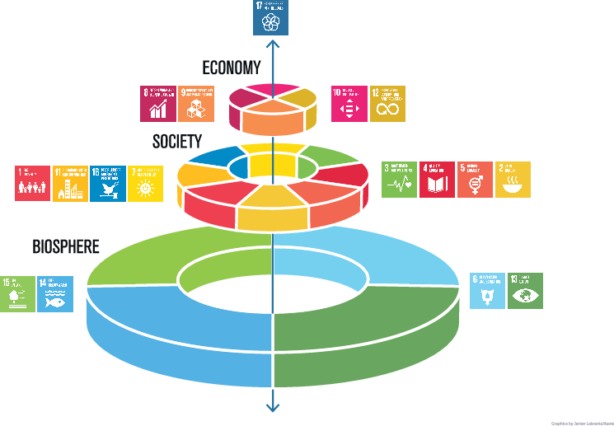
Figure 2 SDGs wedding cake. Source: Stockholm Resilience Centre

Therefore, this work effectively cuts across, and supports, all sectors. However, in terms of water demands and impacts on water, the most relevant sectors include: agriculture (typically 70% of water withdrawals) (SDG 2); energy (particularly relevant for hydropower and dam construction, but also biofuels, and cooling for thermal power (coal and gas)) (SDG 7); industry and mining (both in terms of water demands, and potential pollution) (SDGs 8, 9, 11, 12); and direct human water demand (municipal, commercial and domestic) (SDGs 6, 8, 11, 12).

Associated ‘sectors’ and ‘issues’ that are important to consider in this space include: forestry and land use planning and development (SDG 15); climate change resilience (SDG 13); poverty reduction and employment (SDG 1, 8); human health (e.g. food security and water-borne diseases) (SDG 2, 3); transition to green growth / green jobs (economy and employment) (SDG 8); floods and droughts (SDG 11); peace and security (SDG 16); transboundary collaboration (SDG 6.5); gender and education (SDG 4, 5); marine and coastal (e.g. pollution from land-based sources (e.g. plastics and nutrients), and flood protection (e.g. mangroves)) (SDG 14).

All these sectors and issues are interlinked, with policy/management decisions in one area having an impact on other areas. It is also important to consider that the management of these issues is particularly important at the catchment scale (also known as watershed or basin scale).

IWRM and NbS
Integrated Water Resources Management (IWRM), Ecosystem-based Adaptation (EbA), and Nature-based Solutions (NbS) are crucial approaches to planning and management in this sphere of coordinated water, land and ecosystem management to support multiple development objectives. Further information can be found in The case for integrated water, land and ecosystem management.

Relevant institutions within UNCTs
Given the interlinkages mentioned above, virtually every UN agency has a mandate and programmes that are relevant to this space, as illustrated by the UN Country Team in South Africa, where all 16 UN agencies are part of Results Group 4 on climate resilience and sustainable natural resources management. However, those that typically have a more active role in this space include (in alphabetical order): FAO, UNDP, UNICEF, WFP, WHO, and UNEP. Other agencies that are likely to have a role include, but are not limited to: ILO, UN Habitat, UNIDO, UNECE (hosting the secretariat of the international water conventions), UN Women, WMO and UNESCO.

In assessing the coordination of water, land and ecosystem management within the UNCTs, it is important to understand the mandate, programmes and projects of these different agencies within the national context.

Key data sources
Relevant data sources for assessing existing CCAs and UNSDCFs, and contributing to their review and updates, are gathered in the Database Compendium. Furthermore, it is important to understand UNEP’s prior and current engagement within the country, and the data and information that are already gathered. There is a proposal to gather all relevant information in one database in the Recommendations for Scaling Up note. Both the database compendium and the scaling up note were developed as part of the initial phase of this initiative. The proposed database would also contain information on the stage each country is at within the UNSDCF cycle (see Figure 1), and appropriate entry points.

