Evidence of Success: Nature-based Solutions for multiple development objectives
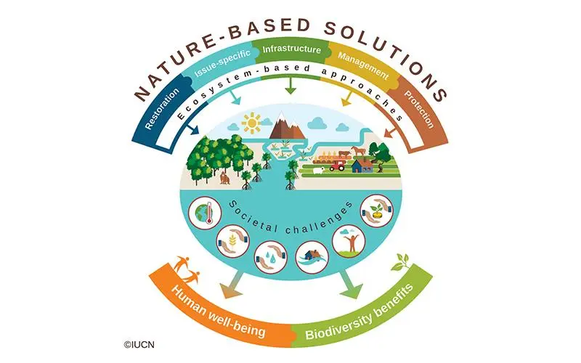
Nature-based Solutions (NbS) are “...actions to protect, sustainably manage, and restore natural and modified ecosystems that address societal challenges effectively and adaptively, simultaneously benefiting people and nature”. The image below depicts some of these actions and their resulting benefits, both for human well-being and biodiversity (animals and ecosystems, for example).
The purpose of this reference document is to provide an overview of how these NbS contribute not only to the goal of safe and reliable water supplies but also greater resilience to water-related disasters (drought, landslides, and flooding) and opportunities in terms of economic growth, employment diversification and cost savings in comparison to conventional or gray solutions.
In providing this overview, the document also aims to equip readers with easily accessible and referenceable evidence and tools for incorporating NbS into their project proposals, strategies, and activities with the aim of galvanizing greater and more diverse stakeholder engagement and support (financial, political, and in-kind) for integrated water, land and ecosystem management initiatives. The document is organized as follows:
- Section One - Economic Growth & Employment: Provides evidence on NbS for boosting economies and creating or diversifying employment opportunities.
- Section Two - Avoided Losses and Damages from Storms, Flooding & Landslides, etc: Demonstrates how nature can reduce vulnerability to water-related disasters.
- Section Three - Cost Savings in Comparison to Conventional Solutions: Compiles examples of NbS around the world that have produced WaSH benefits in a more cost-effective manner than conventional solutions relying on conventional or gray alternatives.
- Section Four - Nature for Safe and Reliable Water Supplies: Focuses on how (1) Forests, (2) Wetlands, and (3) Climate or Water-Smart Production Practices contribute to better water outcomes.

Economic Growth & Employment
NbS are labor intensive to implement, creating more jobs per million dollars invested than most other sectors, making them a key choice for policy makers attempting to address unemployment, especially in contexts of rapid rural-to-urban migration and young populations. Additionally, with nature protection and the uptake of sustainable production practices, countries can see their economic bases become more diversified, with major gains in ecotourism and sustainable farming, forestry, and fishing, to name a few examples. NbS can also substantially boost the value of properties surrounding natural areas. Finally, global GDP is predicted to grow dramatically from investments in nature. Policy makers that wish to produce multiple benefits (safer water, employment, and stronger economies) from their WaSH investments would be wise to endorse projects that incorporate nature into their design.

Achieve higher levels of economic productivity through diversification, technological upgrading and innovation, including through a focus on high-value added and labor-intensive sectors.

- Valuing Nature Conservation: This report discusses a global assessment of economic benefits stemming from nature conservation:
  - Creation of approximately 400,000 to 650,000 jobs in conservation-management fields such as wildlife management and area infrastructure. Through adjacent nature-dependent markets, natural capital could also support local economic growth, generating or safeguarding on the order of $300 billion to $500 billion in GDP and 30 million jobs in ecotourism and sustainable fishing alone.
  - Across scenarios, our analysis suggests that doubling nature conservation could create or safeguard 27 million to 33 million jobs and $290 billion to $470 billion in GDP from ecotourism and sustainable fishing.
  - We find that in 2019, tourism linked to Protected Areas, a subset of the overall ecotourism market, was worth approximately $300 billion in revenues.
  - A review of approximately 150 different studies found that each hectare of mangrove creates around $5,800 of value in water and air purification, $3,600 in coastal protection, and $1,000 in recreation and tourism annually. In addition, mangroves generate hundreds of dollars per hectare each year from carbon sequestration, fishing, and forestry.
- Designing the COVID-19 Recovery for a Safer and More Resilient World: For every US$1 million invested in NbS, close to 40 full-time jobs are created, which is equivalent to around 10 times the job creation rate of investments in fossil fuels (Levy, Brandon, and Studart, 2020).
- NATURE HIRES: How Nature-based Solutions can power a green jobs recovery: This document provides data on how many jobs are generated by the type of Nature-based Solution implemented in South Africa, India, the United States and Canada. Figures from Annex: Job Intensity And Job Returns Of Nature-Based Solutions And Related Activities And Investments:
  - Watershed improvement: 166-500 jobs per $1 million.
  - Afforestation, reforestation, & desertification control: 265-625 jobs per $1 million USD.
  - Creation & management of urban green spaces: 24-250 jobs per $1 million USD.
  - Construction of wetlands for sewage treatment: Same as similar construction work.
- The Economic Case for Nature: Nature-smart policies can reduce the risk of ecosystem collapse and are “win-win” policies in terms of biodiversity and economic outcomes. A combination of carefully crafted and coordinated policies, particularly those supporting innovation, can simultaneously benefit biodiversity and development. The policies considered in this report reduce conversion of natural land and result in a general increase in global real GDP in 2030 that is estimated to be in the order of $50 billion to $150 billion.
- The Economics of Biodiversity: Dasgupta Review: Global review of economic benefits resulting from nature restoration and conservation:
  - They estimate that ecosystem restoration and avoided land and ocean use expansion could deliver 11 million more jobs by 2030 through opportunities such as ecotourism, sustainable forestry management and NbS for mitigating climate change. They also estimate that using Nature as ‘infrastructure’ – which includes incorporating existing or restored ecosystems, such as floodplains, wetlands and forests, into built environments to mitigate against extreme events, for flood control or water filtration – could create an additional 4 million jobs by 2030.
  - In all scenarios studied by Waldron et al. overall gross economic output was found to be US$64-454 billion per year higher by 2050 than in the counterfactual of non-expansion of Protected Areas (Waldron et al. 2020).
  - Wilson and Carpenter (1999) estimated that the benefits of policies that would achieve ‘swimmable’ water quality in all the US fresh waters at the end of last century [were] about US$58 billion per year.
- ‘This is what a river should look like’: Dutch rewilding project turns back the clock 500 years | Rewilding | The Guardian:
  - River restoration in the Netherlands: Helmer says the Gelderse Poort project saw the loss of 30 agricultural jobs but 200 jobs have been gained in tourism and recreation. As well as creating new wild spaces for nature, the project has proved economically valuable: real estate value increased more than 10% faster than elsewhere in the country.
  - The €550m project is being paid for mainly by companies wanting to extract sand and gravel from the riverbed, which has helped widen the river and lower riverbanks and so expand the floodplain. Because of the involvement of industry, Border Meuse was the only large river restoration project that wasn’t withdrawn during the 2008 financial crash. Today, it attracts two million visitors a year, bringing in about €1bn of revenue to the Meuse region.

Avoided Losses and Damages from Storms, Flooding, Landslides, etc.
A city exploring how to treat wastewater or ensure reliable water supplies should factor in the additional disaster-risk reduction (DRR) benefits of NbS when comparing the costs and benefits of different options. For example, NbS can reduce populations’ susceptibility to disasters by decreasing wind speeds, reducing wave strength and height, absorbing rainfall from extreme rainfall events, and preventing landslides, among many other examples, in addition to helping achieve WaSH outcomes.

1.5: By 2030, build the resilience of the poor and those in vulnerable situations and reduce their exposure and vulnerability to climate-related extreme events and other economic, social and environmental shocks and disasters
2.4: By 2030, ensure sustainable food production systems and implement resilient agricultural practices that increase productivity and production, that help maintain ecosystems, that strengthen capacity for adaptation to climate change, extreme weather, drought, flooding and other disasters and that progressively improve land and soil quality
11.5: By 2030, significantly reduce the number of deaths and the number of people affected and substantially decrease the direct economic losses relative to global gross domestic product caused by disasters, including water-related disasters, with a focus on protecting the poor and people in vulnerable situations

13.1: Strengthen resilience and adaptive capacity to climate-related hazards and natural disasters in all countries

- African examples of NbS in action for flood control (to be elaborated): Mozambique (1) (2), Rwanda, Tanzania, Angola, Ghana, South Africa, Malawi, Uganda, Seychelles, Namibia, & Democratic Republic of the Congo.
- Wetlands have saved Australia $27 billion in storm damage over the past five decades: Our recent research shows 54 cyclones struck Australia in the 50 years between 1967 and 2016, causing about $3 billion in damage. We found the damages would have totalled approximately A$30 billion, if not for coastal wetlands.
- Scientific evidence for ecosystem-based disaster risk reduction. Economics articles had the highest overall score of confidence, both in terms of levels of robustness of evidence and agreement, as all these papers provided quantitative (monetary) values to assess ecosystem functions and/or services for DRR (for example, refs. 23,24). In addition, the economics papers demonstrated that ecosystem services and/or functions are cost-effective as well as cost-efficient, particularly with regards to flood mitigation (for example, refs. 25,26), vegetation cover for slope stabilization and avalanche mitigation (for example, refs. 27,28), and storm protection of beaches and foredunes (for example, ref. 24). Note: See Figure 2 for more details.
- McKinsey Report - Valuing Nature: A review of approximately 150 different studies found that each hectare of mangrove creates around $5,800 of value in water and air purification, $3,600 in coastal protection, and $1,000 in recreation and tourism annually. In addition, mangroves generate hundreds of dollars per hectare each year from carbon sequestration, fishing, and forestry.
- Protecting 30% of the planet for nature: costs, benefits and economic implications: A partial economic analysis, focusing only on forests and mangroves, showed that there would be overall benefits of US$170-534 billion per year by 2050 from avoided flooding, climate change, soil loss and coastal storm damage.
- State and Trends in Adaptation Report 2020: In Vietnam, a mangrove plantation project has created 9,500 hectares of forest benefiting approximately 350,000 people while indirectly protecting another 2 million people from flooding.
- Lifelines : The Resilient Infrastructure Opportunity: Investing in climate-resilient infrastructure in low- and middle-income countries can save USD $4.2 trillion-worth of damages from climate impacts – with USD $4 in benefits for each dollar invested.
- POWERING NATURE: CREATING THE CONDITIONS TO ENABLE NATURE-BASED SOLUTIONS: Natural coastal habitats physically stabilize landscapes and coastlines. They help prevent erosion and provide a buffer against storms and flooding – and so, have a critical role in disaster risk reduction. Estimates of the economic value of mangroves for flood risk reduction exceed US$65 billion a year and if mangroves were lost or destroyed, 15 million more people would be flooded annually across the world.
- The Economics of Biodiversity: Dasgupta Review:
  - Wetlands provide many ecosystem services, including water filtration and flood control. During Hurricane Sandy in 2012, wetlands are estimated to have reduced the costs of flood damage by more than US$625 million (Narayan et al. 2017). Studies have shown that the total economic impact of Hurricane Katrina (estimated at US$150 billion) would have been significantly reduced if coastal wetlands in the region had been preserved (UNEP Finance Initiative, 2008). It is estimated that protecting coastal wetlands could save the insurance industry US$52 billion a year through reduced losses from storm and flood damage (Barbier et al. 2018).
  - A number of financial and economic benefits have been found from expanding Protected Areas: ecotourism income, the provision of health clinics, education, improved health outcomes, and other forms of support to local communities, and the avoidance of spending on natural disaster prevention and recovery (e.g. flood defenses, storm damage mitigation, for example Barbier, 2016; Reguero et al. 2018). In all scenarios studied by Waldron et al. overall gross economic output was found to be US$64-454 billion per year higher by 2050 than in the counterfactual of non-expansion of Protected Areas (Waldron et al. 2020).
  - There has also been significant investment in cross-regional payments for ecosystem service schemes (PES), known in China as ‘eco-compensation’ programmes (Leshan et al. 2017, 2018). The Sloping Land Conversion Programme is one of the largest PES initiatives in the world. By the end of 2012, the total area of afforested land was a little under 30 million hectares, with total investment of around 440 billion yuan (approximately US$66 billion at current exchange rates), of which approximately 325 billion yuan was paid directly to 32 million households in 25 provinces (Liu and Lan, 2015). The programme aimed to reduce soil erosion, deforestation and flood risk by restoring forests and grasslands. Evidence suggests the conversion of land through this payments programme, from cropland to forest and grassland, has sequestered significant amounts of carbon, reduced soil erosion into the Yangtze and Yellow Rivers, and reduced flood risk (Song et al. 2014; Gutiérrez Rodríguez et al. 2016).

Cost Savings in Comparison to Conventional Solutions
One of the main reasons for the difficulty of achieving WaSH outcomes is their cost. For example, a centralized water treatment plant can cost billions of dollars to construct, operate, and maintain over time. Fortunately, NbS are often more economical upfront than “conventional” WaSH and gray infrastructure solutions, or they end up being more cost-effective within a short payback period, as they are largely self-regenerating and require less maintenance. Any WaSH practitioner or policy maker, with budget constraints or not, should take this into account when making decisions on the allocation of funding, as their decisions will have a real impact on the prices their constituents pay for access to water.

1.5: By 2030, build the resilience of the poor and those in vulnerable situations and reduce their exposure and vulnerability to climate-related extreme events and other economic, social and environmental shocks and disasters
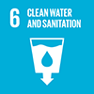

6.1: By 2030, achieve universal and equitable access to safe and affordable drinking water for all
9.1 Develop quality, reliable, sustainable and resilient infrastructure, including regional and transborder infrastructure, to support economic development and human well-being, with a focus on affordable and equitable access for all

11.5: By 2030, significantly reduce the number of deaths and the number of people affected and substantially decrease the direct economic losses relative to global gross domestic product caused by disasters, including water-related disasters, with a focus on protecting the poor and people in vulnerable situations

13.1: Strengthen resilience and adaptive capacity to climate-related hazards and natural disasters in all countries

- Valuing Nature Conservation: Conserving nature can also avoid costs. In the early 1990s, for example, New York City officials collaborated with upstate farmers on an effort to improve water quality. The farmers set aside land for conservation and introduced sustainable farming practices, resulting in a large watershed-filtration area providing approximately 1.2 billion gallons of clean water daily for New York City. The alternative option available to policy makers at the time was to build a large-scale water filtration system that would have required around $5 billion in initial capital and $250 million in annual operating costs (Note: 10 times the cost of NbS).
- Science for Environment Policy: In the Maldives, building a seawall cost $2.2bn. After 10 years of maintenance, it would’ve been four times cheaper to preserve the natural reef.
- Mangrove restoration and rehabilitation for climate change adaptation in Vietnam: The restoration of 12,000 ha of mangroves has saved an estimated US$7.3 million/year in dyke maintenance, a figure that is more than six and a half times the costs of planting.
- An Economic Analysis of Ecosystem-based Adaptation and Engineering Options for Climate Change Adaptation in Lami Town, Republic of the Fiji Islands: Technical Report. Tables comparing natural solutions’ costs to that of conventional, gray solutions:

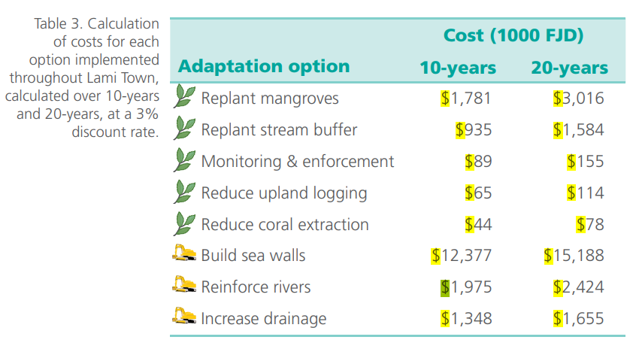

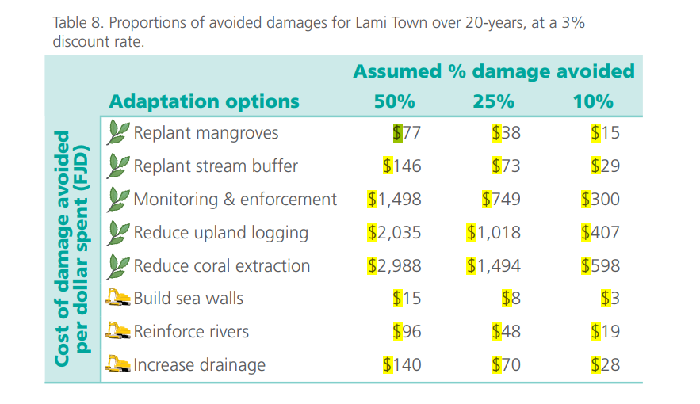
- Harnessing nature to help people adapt to climate change.
  - Finally, hard solutions typically require periodic and often costly maintenance33 and may have short life cycles35, whereas EbA are more typically self-renewing and often require lower-cost ongoing management. For instance, the annual cost of maintaining mangrove forests in Vietnam is estimated at US$7.50 per hectare36 and the annual cost of maintaining a sea dyke is US$287.50 per hectare37.
  - An economic analysis in the Nam Dinh Province of Vietnam suggested that restoring mangroves would cost US$166 per hectare in planting, capital and maintenance, but would provide benefits totalling US$630 per hectare. These benefits included not only the avoided costs of sea dyke upkeep but also the livelihood co-benefits of timber and honey provisioning and fish-stock maintenance23. A similar analysis calculated that restoration of the Skjern River floodplain in Denmark would cost US$44.2 million but provide net-present benefits of US$2.3 million in avoided water pumping (at present used to prevent flooding) and US$84.6 million in co-benefits including hunting, fishing, recreational opportunities and biodiversity conservation24.
  - In coming decades, climate change is expected to increase the frequency of the most powerful tropical storms16, making the protective role of the reefs and their conservation even more critical. If they were lost, the cost of building hard infrastructure such as seawalls, breakwaters and other forms of coastal protection to replace the natural reefs has been estimated at US$1.6 billion–2.7 billion (ref. 17). In contrast, conserving the reefs to prevent their on-going degradation as a result of pressures ranging from overfishing to coral mining, through establishment of marine protected areas, would cost ∼US$34 million in start-up and ∼US$47 million annually (scaled up from calculations for a smaller protected area in the Maldives)18, would maintain their critical protection service and could generate ∼US$10 billion per year in co-benefits through tourism and sustainable fisheries17.
- Economic valuation for policy support in the context of ecosystem-based adaptation to climate change: An indicator, integrated based approach. Screenshot of NbS costs for easy comparison to conventional solutions:
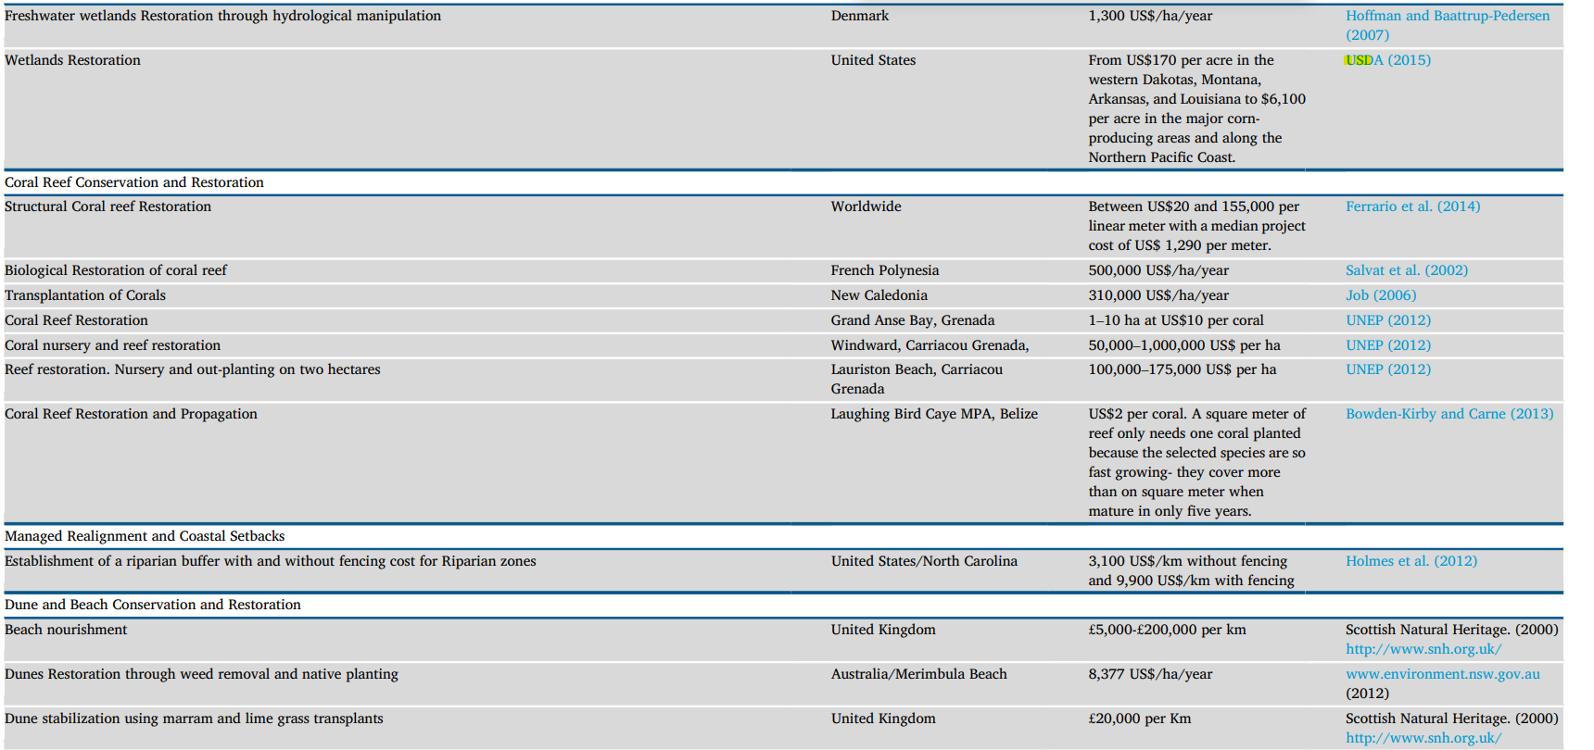
- UNEP CityAdapt
  - CityAdapt Project in San Salvador, El Salvador:
    - Detention pond vs. manually dug infiltration ditches: Cost comparison:
      - Constructed detention pond: 21.9 million USD for 220,000 cubic meters of water storage
      - Vegetation-covered infiltration ditches: $1,472,500 USD for 110,000 cubic meters of water storage, equaling about 3 million USD for 220,000 cubic meters of water storage
      - Conclusion: Vegetation-covered infiltration ditches cost $19 million USD less than the conventional option for same water storage
  - CityAdapt Project in Xalapa, Mexico: Cost comparison of rooftop capture vs. construction of water pipeline from faraway source. Rooftop capture systems on all roofs are cheaper than an alternative water pipeline within three years, approximately.
- Valuation of Ecosystem Services of the Maha Oya: In Sri Lanka, long-term climate adaptation benefits and costs saved were found to be more than twice as high as the costs of conserving coastal and estuarine ecosystems.
- The Economics of Biodiversity: Dasgupta Review. Excerpts:
  - There is evidence that NbS can provide large social benefits by reducing coastal risks due to climate change and development. In the Gulf of Mexico, USA, where such risks are increasing, the cost-effectiveness of adaptation measures were compared, including oyster reef or wetland restoration, gray infrastructure, and policy measures such as home elevation (Reguero et al. 2018). Flooding costs were predicted to be US$134–176.6 billion in 2030, with annual costs expected to double by 2050 due to increasing risks. The NbS compared favorably with engineered solutions; average benefit-cost ratios for NbS were above 3.5. Cost-effective coastal adaptation measures could prevent US$57–101 billion in losses; NbS could avert more than US$50 billion of these costs (Reguero et al. 2018).
  - Eight restored rivers in Europe, for instance, were found to provide net social economic benefits over unrestored rivers, of €1,400 ± 600 ha -1 yr -1 associated with an increase in cultural and regulating services, while provisioning services remained the same (Vermaat et al. 2016). Analysis of the flood alleviation potential of ecosystem-based adaptation of two river catchments in Fiji found that NbS were more cost-effective than hard infrastructure options. Planting riparian buffer vegetation was the most cost-effective option, yielding benefit-cost ratios of between 2.8 and 21.6. Upland afforestation provided the greatest benefits overall, yielding net present values between 12.7 and 101.8 million Fijian dollars (approximately US$6.1-48.9 million). Of the hard infrastructure options, river dredging provided the greatest benefits, but costs were high relative to the benefits, and the benefits were only accrued in part of the catchment downstream (Daigneault, Brown, and Gawith, 2016).
  - A spatial analysis of cost-effectiveness of dryland forest restoration for multiple ecosystem services found that natural regeneration provided positive net social benefits, worth between US$1million and US$42million, and a benefit-cost ratio of above four. Active restoration was less cost-effective due to the additional labor, materials and opportunity costs from lower agricultural production.
- Benefits of investing in ecosystem restoration:
  - After screening over 200 studies, we examined the costs (94 studies) and benefits (225 studies) of ecosystem restoration projects that had sufficient reliable data in 9 different biomes ranging from coral reefs to tropical forests. Costs included capital investment and maintenance of the restoration project, and benefits were based on the monetary value of the total bundle of ecosystem services provided by the restored ecosystem. Assuming restoration is always imperfect and benefits attain only 75% of the maximum value of the reference systems over 20 years, we calculated the net present value at the social discount rates of 2% and 8%. We also conducted 2 threshold cum sensitivity analyses. Benefit-cost ratios ranged from about 0.05:1 (coral reefs and coastal systems, worst-case scenario) to as much as 35:1 (grasslands, best-case scenario). Our results provide only partial estimates of benefits at one point in time and reflect the lower limit of the welfare benefits of ecosystem restoration because both scarcity of and demand for ecosystem services is increasing and new benefits of natural ecosystems and biological diversity are being discovered. Nonetheless, when accounting for even the incomplete range of known benefits through the use of static estimates that fail to capture rising values, the majority of the restoration projects we analyzed provided net benefits and should be considered not only as profitable but also as high-yielding investments.
  - Results of our sensitivity analyses showed that even under a worst-case scenario (i.e., discount rate of 8%, 100% of the maximum cost, and a restoration benefit of 30% of the TEV), investing in restoration still breaks even or provides a financial profit (in TEV) in 6 of the 9 ecosystem types (Table 2). Only coral reefs and coastal systems had IRRs that were negative (Fig. 2a). In the best-case scenario (discount rate of −2%, 75% of the maximum cost, and restoration benefit of 75% of the TEV), restoration yielded a positive benefit to cost ratio in all the ecosystem types considered. We therefore assert that our results are robust and supported by many well-documented case studies (e.g., Aronson et al. 2007; Farley & Gaddis 2007; Goldstein et al. 2008). For example, actors in both the private and public sectors are undertaking coral reef restoration in many marine protected areas and ports around the world, which suggests a positive rate of return for marketable benefits alone (Bottema & Bush 2012)... Very high benefit-to-cost ratios were found for restoration of most ecosystems, provided the benefits (and values) of public goods, services of these ecosystems, and social returns on investment were included. There is also a large but as yet little explored potential in urban landscapes to restore ecological processes, functions, and services.
- Scientific evidence for ecosystem-based disaster risk reduction: Economics articles had the highest overall score of confidence, both in terms of levels of robustness of evidence and agreement, as all these papers provided quantitative (monetary) values to assess ecosystem functions and/or services for DRR (for example, refs. 23,24). In addition, the economics papers demonstrated that ecosystem services and/or functions are cost-effective as well as cost-efficient, particularly with regards to flood mitigation (for example, refs. 25,26), vegetation cover for slope stabilization and avalanche mitigation (for example, refs. 27,28), and storm protection of beaches and foredunes (for example, ref. 24).

Nature for Safe & Reliable Water
Air currents in the atmosphere carry moisture around the world. Forests pump water collected from the land into the atmosphere, triggering rain upon contact with those currents. This rain falls on forests and surrounding areas where it is captured and purified, infiltrating into the water table and aquifers and slowly being released over time for human and biodiversity needs or back into the atmosphere for more rainfall. Wetlands use their complex root systems with high surface areas as excellent natural filters for capturing and removing a wide variety of pollutants from water, often much more effectively than treatment plants. NbS techniques like half-moons, bunds, agroforestry planting, and riparian restoration, to name a handful of examples, can decrease producers’ vulnerability to drought and water scarcity by mimicking forests and wetlands, capturing, cleaning and storing water in the soil or avoiding losses to evaporation. Finally, by making water more available locally, women are not forced to spend hours of their time fetching water and exposing themselves to threats.

6.1: By 2030, achieve universal and equitable access to safe and affordable drinking water for all
6.2: By 2030, achieve access to adequate and equitable sanitation and hygiene for all and end open defecation, paying special attention to the needs of women and girls and those in vulnerable situations
6.3 By 2030, improve water quality by reducing pollution, eliminating dumping and
minimizing release of hazardous chemicals and materials, halving the proportion of
untreated wastewater and substantially increasing recycling and safe reuse globally
6.5 By 2030, implement integrated water resources management at all levels,
including through transboundary cooperation as appropriate
Forests
- Influence of Land-Surface Evapotranspiration on the Earth's Climate: Calculations with a numerical model of the atmosphere show that the global fields of rainfall, temperature, and motion strongly depend on the land-surface evapotranspiration. This confirms the long-held idea that the surface vegetation, which produces the evapotranspiration, is an important factor in the earth's climate.
- Trees, forests and water: Cool insights for a hot world: Approx. 40% of rain over land comes from evaporation and the transpiration of water from plants.
- Forests create and maintain conditions for more rainfall (at least twice as much after air has passed over extensive vegetation), and clearing vegetation does the opposite by reducing overall water across landscapes, meaning less available for evapotranspiration and thus less rainfall is triggered. Evidence from Australia and Amazon.
- The rainforest's water pump: The humid tropics contain more than 35% of global forests, covering an area of 11,564,000 square kilometers (ref. 1). Tropical trees can extract deep soil water and pump it back to the atmosphere through a process called evapotranspiration. As a result, 25–56% of the rainfall in these regions can be recycled within the ecosystem.
- Evidence for the effectiveness of nature-based solutions to water issues in Africa: A systematic review of over 10 000 publications revealed 150 containing 492 quantitative case studies related to the effectiveness of nature-based solutions for downstream water quantity and water quality (including sediment load) in Africa. The solutions assessed included landscape-scale interventions and patterns (forests and natural wetlands) and site-specific interventions (constructed wetlands and urban interventions e.g. soakaways). Consistent evidence was found that nature-based solutions can improve water quality. In contrast, evidence of their effectiveness for improving downstream water resource quantity was inconsistent, with most case studies showing a decline in water yield where forests (particularly plantations of non-native species) and wetlands are present. The evidence further suggests that restoration of forests and floodplain wetlands can reduce flood risk, and their conservation can prevent future increases in risk; in contrast, this is not the case for headwater wetlands. Potential trade-offs identified include nature-based solutions reducing flood risk and pollution, whilst decreasing downstream water resource quantity. The evidence provides a scientific underpinning for policy and planning for nature-based solutions to water-related risks in Africa, though implementation will require local knowledge.
- Projects in African countries using forests and urban greening for reliable water supplies: Senegal (1) (2), Algeria, Cameroon, Madagascar, Malawi, Sierra Leone, & South Africa

Wetlands
- Water Purifying Capacity of Natural Riverine Wetlands in Relation to Their Ecological Quality:
  - We sampled water, macroinvertebrates, and diatoms, to compare sites before joining the wetland, within the wetland and after passing through the wetland. Considering both seasons, up to 74% TP, 73% DIN, and 77% BOD reduction was recorded. The lower concentration of nutrients, and BOD in sites after joining the wetland showed the presence of pollution attenuation.
  - Generally, this study confirmed the potential of natural wetlands to mitigate nutrients and organic pollutants and sustain biodiversity. However, when the incoming water is heavily degraded, the retention of pollutants seriously affects the wetland’s ecological quality.
- The Role of Engineered Wetlands for Water Treatment: The Town of Bishop’s Falls in Newfoundland and Labrador had a series of outfalls that discharged directly into a freshwater river which is home to the largest population of North Atlantic Salmon in the world. The Town was looking for solutions that would provide high-quality effluent, while minimizing any increases to operational costs for the new facility. Engineered wetlands were chosen as the preferred solution, and by replicating the structures in natural wetlands, engineered wetlands encourage diverse and dense microbial growth within the hydraulically active zones of the wetland. With wetlands about the size of 15 hockey rinks, the Bishop’s Falls facility now releases effluent averaging below 10/10 mg/L TSS and BOD, far below the provincial regulations.
- Wastewater Treatment Using Constructed Wetland: Current Trends and Future Potential: However, the [farmers] are usually in conflict with these government bodies regarding the regulation and operation of the agricultural schemes. The runoff from agriculture schemes contributes negatively to the quality of the receiving water bodies. The negative effect in the receiving waters can occur as a change in salinity or excess nutrients. Constructed wetlands can be used as a receiving water body that contributes to reducing the nutrients in the runoff and decreases the erosion effect. CWs can provide a shade for the agricultural schemes and minimize the adverse effect of the foods.
- Wetlands: Water "living filters"? (CWS = Constructed Wetlands):
  - The case studies for treatment of waters contaminated with special organic compounds display a variety of applications for constructed wetlands. The reported removal efficiencies of organic xenobiotics show in many cases surprisingly good results, with values above 70% being frequently achieved in these studies.
  - Removal efficiencies reported in CWS studies present some variation, from quite low values (~ 25%) to nearly complete removal of some metals. In general, however, the efficiencies are high (> 70%) but these will depend, as usual, on varied factors such as the influent metal loads, the type of vegetation used, the CWS type and on environmental conditions. Obviously, better removals will be achieved when the systems are specifically designed and optimized to solve well-defined metal contamination problems such as mine drainage, where well-known metal accumulator plants will be used preferably, in comparison with systems designed for broader treatment targets…
  - Tables with reduction rates of different pollutants:
    - 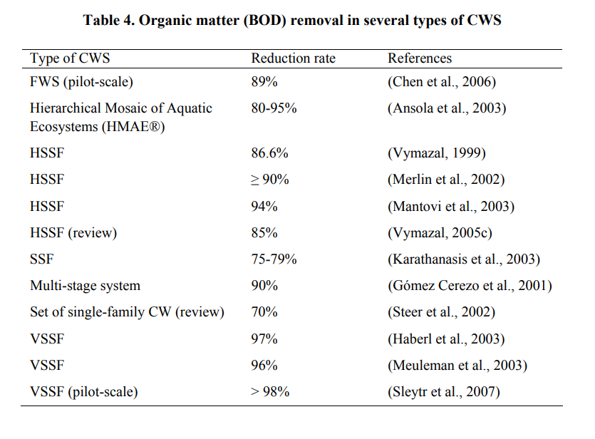
    - 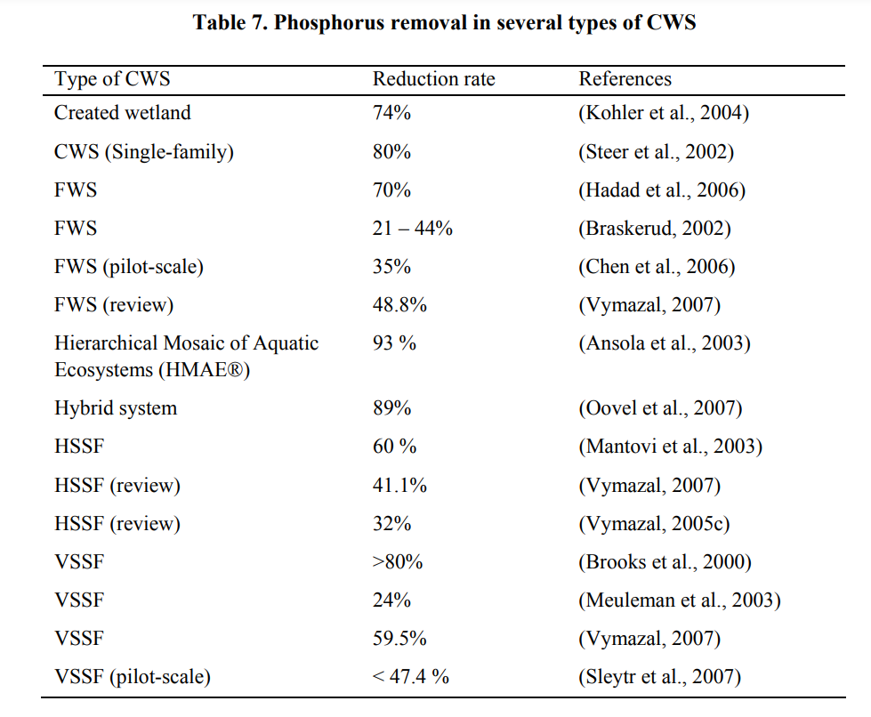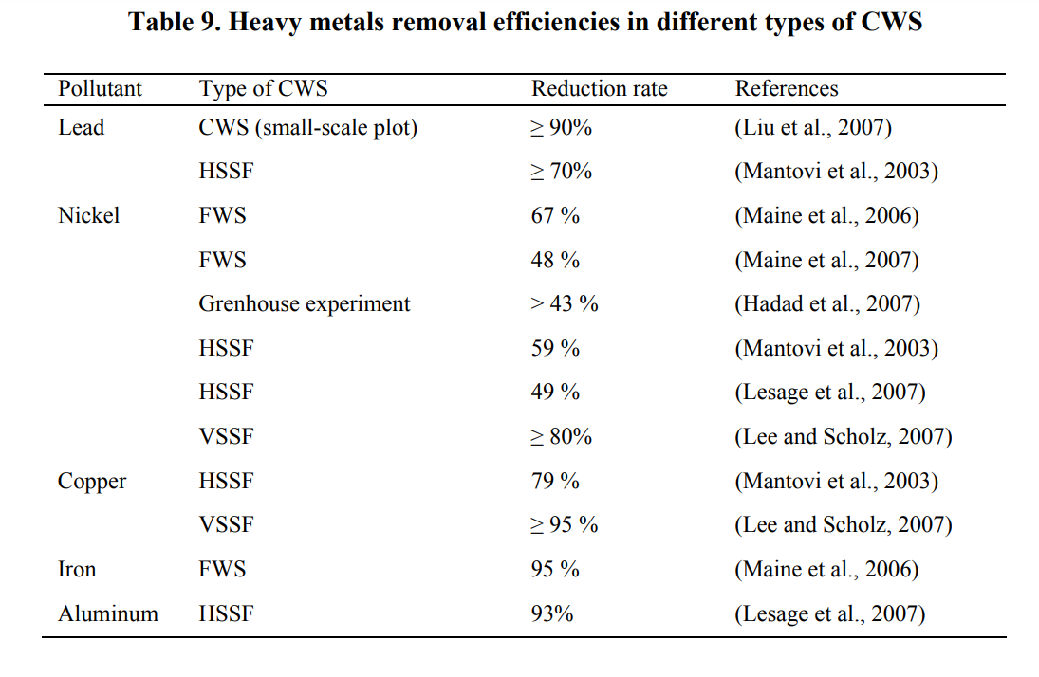
    - 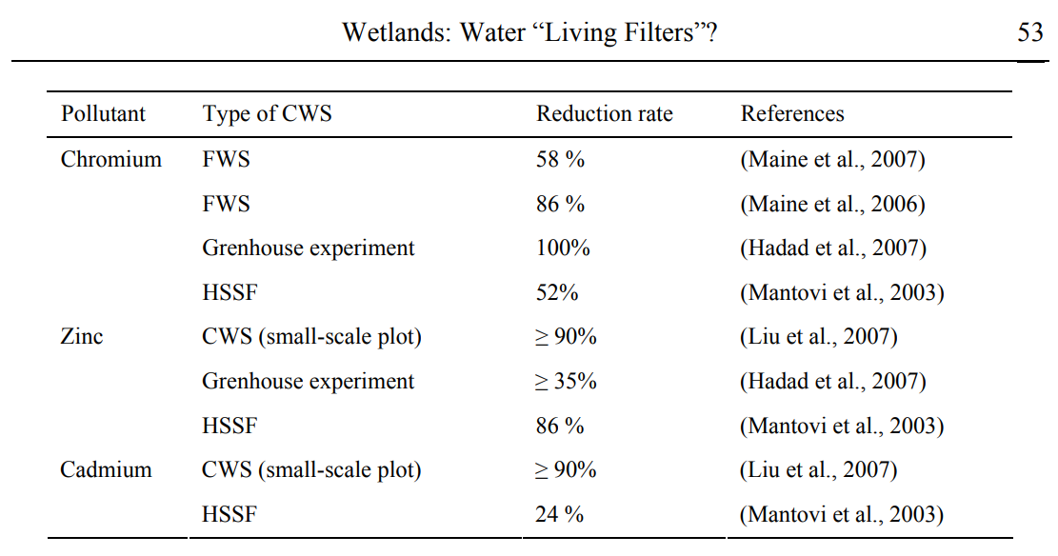
- A review on constructed wetlands-based removal of pharmaceutical contaminants derived from non-point source pollution. Tables with removal efficiencies:
  - 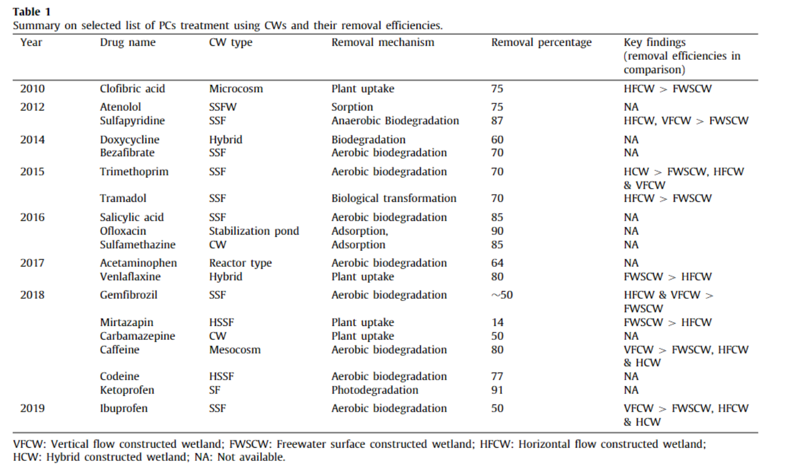
- African examples of projects using wetlands to improve water quality: South Africa, Rwanda, Tanzania, Angola, Ghana, & Mauritania (dunes to prevent saltwater intrusion).
Climate-smart/Ecological Farming
- The Economics of Biodiversity: Dasgupta Review: Analysis of water collection data suggested that the conversion [of forests] to pasture cost the villagers 38 million liters of water every dry season, with an estimated annual value of US$130,000 (Becker, 1999). Presentations of this to the community alarmed them. The villagers took a vote on establishing a forest reserve and banning clearance, logging and hunting. The cabildo had to consider and address the concerns of the villagers who made a living from the forest through hunting, timber and charcoal, and did so by offering them jobs associated with the reserve, such as forest guards. In 1996, after three months and four meetings, the community voted unanimously in favor of the forest reserve (Becker, 1999; Becker and Ghimire 2003; Becker et al. 2005; Balmford, 2012). It has since been expanded twice so that it now covers 40% of their land.
- Farmer Managed Natural Regeneration A holistic approach to sustainable development: Testimonial from beneficiary: “After the project, we have got good rain, good crop production, fresher air, and water for livestock. All of the weather conditions for humans and animals have become good.” – Male Farmer, Humbo, Ethiopia
- Farmers’ perspectives and context are key for the success and sustainability of farmer-managed natural regeneration (FMNR) in northeastern Ghana: Farmers’ perceptions of benefits of FMNR (notice increased rainfall agreed on by both genders):
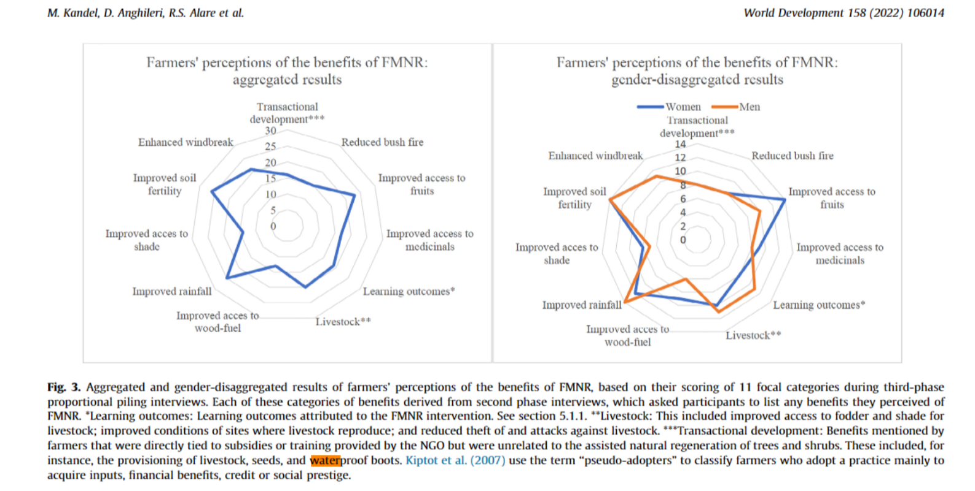

- Agroforests protect watersheds: Center scientists Lisa Tanika, Chandra Irawadi Wijaya, Elissa Dwiyanti and Ni’matul Khasanah used a Generic River Flow hydrological model to log water levels and storage in the landscape at Bialo, where more than 58% of the land is covered with agroforests. They found that in the 21 years between 1989 and 2009, hydrological functions at Bialo remained stable and healthy, with evapotranspiration rates averaging 717.4 millimeters a year, accounting for 42.3% of precipitation, while quick surface soil flows accounted for 287.7 mm, or 17%. Slow flows—water that infiltrates into the soil and slowly seeps to the river—were 694.3 mm or 40.9%. Total precipitation rates varied between 1142 and 2668mm. Breaking down the data, evapotranspiration between 1989 and 2009 decreased by 2.6% and surface soil flows rose 2.4%, while slow flows tended to be relatively stable. The scientists predicted that those trends would stay relatively intact if ground-cover ratios remained as they were between 2010 and 2020—a ‘business as usual’ scenario—with evapotranspiration falling 3.3%, surface flows increasing 9.5% and slow flows falling 1.7%. However, under a scenario in which 50% of the agroforests were converted to undergrowth by 2020, surface flows would rise 26.8%, evapotranspiration would fall by 7.7% and slow flows by 6.9%, creating an elevated risk of flooding, erosion or other water-caused disasters. If all the land under agroforests were converted to scrub, surface flows would increase by more than half, and slow flows would fall by 14.2% and evapotranspiration by 15.8%.
- Agroforestry is water-wise farming: Annual crops can only use a certain portion of available water. For example, in India, sorghum transpiration accounts for 41% of rainfall while in Niger millet transpiration accounts for 6 to 16% of the annual rainfall, with the remainder going to evaporation, runoff and drainage. The integration of certain trees into these agricultural systems can capture a much larger amount of this rainfall. Research has shown that combinations such as Grevillea trees with maize can utilize 70 per cent of annual rainfall.
- Conserving Soil and Water with No-till and Crop Residue:
  - With continuous no-till, the improved soil structure and residue cover will enhance productivity and profitability even more. Too often soils dry to the depth of tillage. An average silt loam soil holds about 2 inches of plant-available soil moisture per foot of soil. Tilling the soil can result in a loss of 1/2 to 3/4 inch of soil moisture with each trip. With multiple tillage trips, there may not be adequate soil moisture in the seed zone for uniform germination and emergence even though there may be sufficient moisture the rest of the year. Greater yet are the soil moisture losses from evaporation once tillage destroys residue cover. Tillage also breaks up soil structure and pulverizes the soil surface, creating a condition that seals the soil, resulting in more runoff and less effective rainfall or irrigation.
  - More than 3.75 inches of water was applied in 90 minutes on continuous no-till before runoff started, compared to only 1.0 inch of water applied in 20 minutes on plowed ground.
- Sustainable Flood Management and Risk Reduction Action (using techniques such as bunds, contour strips, balleys, etc.) in context of Somalia:
  - Increased returns from dry land farming, improved water supply, enhanced knowledge and capacity of local ministries and NGOs on flood control and management (through catchment conservation)
  - Soil erosion prevention and facilitating growth of vegetation for pastures (from check dam application, although specific metrics not recorded)
  - Agricultural land gain as a result of the construction of gabions, also visibly prevented soil erosion and the extension of the gully into the agricultural areas.
  - Reduction in water price by 77%, on average (ballys for water capture and storage)
  - A total of 17,500 cubic meters of water for livestock and other domestic uses made available to 5,000 families (through construction of 4 catchment dams)
  - Increasing available water for household consumption by household consumption by 83% and the average time taken to fetch water decreased, from 3.5 hours to 20 minutes (ballys for water capture and storage)
- Burkina Faso: Green corridors in city to reduce runoff while providing urban agroforestry opportunities

https://www.iucn.org/our-work/nature-based-solutions

